DESIGN AND IMPLEMENTATION OF A WEB-BASED SIWES LOGBOOK FOR UNIVERSITY STUDENTS

BY

S/N | NAME | MATRIC NO
1 | ADEBAYO ERINAYO FEYISAYO | 22120101007
2 | ADEBOWALE TEMITOPE THOMAS | 22120101008
3 | SANYAOLU JAMAL OLATUNBUSUN | 22120101092

THE DEPARTMEMT OF COMPUTER SCIENCE, COLLEGE OF INFORMATION AND TECHNOLOGY EDUCATION (COITED),
LAGOS STATE UNIVERSITY OF EDUCATION (LASUED) – LAGOS,
LAGOS STATE, NIGERIA.

CHAPTER ONE
INTRODUCTION

1.1 Background of the Study
The Students Industrial Work Experience Scheme (SIWES) is a vital initiative designed to give university students in Nigeria real-world industrial experience related to their degree programs. It facilitates communication between classroom theory and practical industrial applications. Students must keep a diary detailing their daily actions during the training session as part of SIWES requirements.
SIWES logbooks are typically filled out by students by hand on paper, checked by industrial supervisors, and evaluated by academic supervisors. While this system has been in use for decades, it presents various issues, such as loss or damage of logbooks, falsification of entries, delayed supervision, and difficulties in effective assessment.
The development of information and communication technology (ICT), web-based solutions have emerged as essential instruments for administrative and academic process management. By using a web-based SIWES logbook system, SIWES records can become more efficient, transparent, accessible, and secure. The goal of this project is to design and build a web-based SIWES logbook system that enables administrators to efficiently manage SIWES data, supervisors to remotely monitor progress, and students to register daily activities online.

1.2 Statement of The Problem
An essential part of university education is the Students Industrial Work Experience Scheme (SIWES), which gives students real-world industrial exposure. Despite its significance, a manual, paper-based logbook method is still mostly used to record and track SIWES operations. Over time, it has become clear that this conventional method is unreliable and ineffective.
The manual SIWES logbook system is prone to several challenges, including loss or damage of logbooks, incomplete or inaccurate record-keeping, and falsification of entries by students. In addition, supervisors are unable to monitor students’ activities in real time, which often leads to delayed feedback and ineffective supervision. The assessment process also becomes tedious and time-consuming for academic supervisors due to the absence of centralized and well-organized records.
Furthermore, the lack of a secure and centralized data storage system makes retrieval of SIWES records difficult and exposes the data to unauthorized access or manipulation. These problems reduce the effectiveness of the SIWES program and hinder proper evaluation of students’ industrial training performance. Therefore, there is a need for a reliable, secure, and efficient web-based SIWES logbook system that can address these challenges by improving documentation, supervision, monitoring, and assessment processes.

1.3 Aim and Objectives of the Study
In order to digitize the recording, oversight, and evaluation of students' industrial training activities, the main goal of this project is to create and deploy a Web-Based SIWES Logbook System that is safe, centralized, and easy to use.
Particular goals include:
- Creating an online platform for students to report their daily SIWES activities.
- Create a safe mechanism for students, managers, and other stakeholders to engage with. those in charge.
- Permit supervisors to examine, remark on, and authorize students logbook statements. On the web.
- Give administrators the resources they need to control users and produce SIWES performance summaries.
- Assure the safe management, retrieval, and storage of SIWES records.
- Boost the efficacy, efficiency, and transparency of SIWES oversight and analysis.

1.5 SIGNIFICANCE OF THE STUDY
The adoption of a Web-Based SIWES Logbook is very important since it updates Nigerian institutions' industrial training framework. Many stakeholders gain greatly from this study:

1.5.1 To the Learners:
Data Security: Since all data is backed up in the cloud, students no longer have to worry about losing their physical logbooks to theft, fire, or wear and tear.
Portability: Students can use a laptop or smartphone to update their logs at any time and from any location, which makes it simpler to document activities while the experience is fresh.
Instant Feedback: Unlike the manual system where comments are only seen during physical visits, students receive real-time corrections and guidance from their supervisors

1.5.2 In reference to the supervisors of the industry:
• Administrative Ease: No paper documents are required. Supervisors can save time during a hectic workday by reviewing and approving logs with a few clicks.
• Improved Communication: It offers an organized way to discuss the student's behavior and technical development with the university.

1.5.3 To Coordinators and the University:
• Improved Monitoring: Without the urgent need for expensive and time-consuming travel, coordinators can keep an eye on students assigned to faraway places.
• Efficient Record Management: It makes it easier to create statistics, confirm student placements, and preserve documents for later use or accreditation.
• Assessment Integrity: By timestamping entries, the system ensures that students participate in the program every day and eliminates "log dumping," which involves writing all entries at the conclusion of the program.

1.6 Scope and Limitations
• Study Scope
• The system includes:
• Enrolment of students
• Management of supervisors
• submittal of the logbook
• Upload of the report
• Evaluation and scoring
• Administration

1.7 Limitations of Study
• requires the ability to access the internet
• depends on computer systems' accessibility.
• Basic computer experience is required of users.
1.8 Operational definition of terms
• SIWES (Students Industrial Work Experience Scheme): A skills training program designed to expose and prepare students of universities and other tertiary institutions for the industrial work situation they are very likely to meet after graduation.
• Logbook: A formal record used to document daily activities, technical skills acquired, and observations made by a student during their industrial attachment.
• Industry Supervisor: A designated professional at the place of attachment (the company) responsible for overseeing the student's daily work and validating their logbook entries.
• Institutional Coordinator: An academic staff member from the student's university department who monitors the student's progress and ensures the attachment aligns with academic goals.
• ITF (Industrial Training Fund): The Nigerian federal agency responsible for managing the SIWES program, establishing the guidelines, and providing funding for student stipends.
• Web-Based Application: A software program that runs on a remote server and is accessed by users through a web browser (like Chrome or Safari) over the internet.
• Frontend: The "client-side" of the application; it refers to everything the user sees and interacts with on the screen (built with HTML, CSS, and JavaScript).
• Backend: The "server-side" of the application; it handles the logic, database interactions, and authentication that happen behind the scenes.
• Database (RDBMS): A structured collection of data stored in a computer. In this project, a Relational Database Management System (like MySQL) is used to link students to their respective logs and supervisors.

CHAPTER TWO
LITERATURE REVIEW
2.1 INTRODUCTION
This chapter covers prior research on digital monitoring platforms used in higher education, industrial training management systems, and electronic logbook systems. The purpose is to examine prior research, identify their merits and flaws, and illustrate the necessity for an upgraded e-SIWES Logbook System.
2.2 REVIEW OF RELATED WORKS
2.2.1 Adekunle K. O., Ganiyu M., Enigbokan O.Y. (2024)
Title: Development of Electronic Logbook System for SIWES (Federal Polytechnic Ile-Oluji)
Method: Web-based system using PHP, MySQL, HTML, and CSS
Strengths:
- Improved accessibility
- Decreased forgeries.
- Enhanced supervisor monitoring
- Weaknesses:
- Limited to one institution
- Lack of scalability

2.2.2 Afolayan A. H., Onoriode T. M. (2025)
Title: Web-based SIWES Logbook with Secure Authentication and Role-based Access (FUTA)
Method: Role-based access control system with authentication
Strengths:
- Strong security implementation
- Clear role separation (students vs supervisors)
- Weaknesses:
- Requires stable internet.
- Not suitable for low-connectivity environments
2.2.3 Abdur-Rasheed A. O. (2025)
Title: Design and Implementation of an E-Logbook for UNILORIN
Method: ICT-based logbook system for large-scale usage
Strengths:
- Solves storage and retrieval issues.
- Supports multi-faculty operations.
Weaknesses:
- Prototype stage only.
- Limited real-world testing
2.2.4 Computer Science Project (Nigeria, 2023)
Title: Design and Implementation of Electronic Logbooks for SIWES
Method: PHP and SQL Server with top-down approach
Strengths:
- Addresses data manipulation and storage issues
- Includes implementation details (source code)
Weaknesses:
- Not peer-reviewed
- Limited academic validation
2.2.5 Mohammad Jamiu (2026)
Title: SIWES Logbook for Quantity Surveying: Practical Guide
Method: Manual usage guide with examples and sketches
Strengths:
- Practical and user-oriented
- Bridges theory and real-world application
Weaknesses:
- No ICT innovation
- Not a system design
2.3 THEORETICAL FRAMEWORK
This study is grounded in the following theoretical concepts:
Information system theory:
Describes the methods used in digital systems to gather, process, store, and distribute data. Both user engagement and organized data management are essential to the e-SIWES logbook.
Client-server architecture:
Users (students and supervisors) communicate with a centralized database server through the system's web-based design.
Role-based access control (RBAC):
Ensures that users have access only to functionalities relevant to their roles (student, supervisor, admin), improving system security.
Human-Computer Interaction (HCI):
Focuses on usability and user-friendly interface design to enhance user experience.
2.4 SUMMARY OF FINDINGS
From the reviewed literature, electronic logbook systems provide significant advantages over manual methods, including:
Strengths Identified:
- Reduction in paperwork
- Improved data accuracy
- Real-time monitoring
- Better communication between students and supervisors
- Increased accountability and transparency
- Weaknesses Identified:
- Heavy dependence on internet connectivity
- Inadequate security in some systems
- Poor mobile optimization
- Scalability limitations
- The high expense of creating secure systems.
Despite existing solutions, most systems fail to integrate security, scalability, mobile responsiveness, and institutional integration into a single platform. Additionally, a lot lack proper testing and user-friendly interfaces.
Therefore, this project proposes an enhanced e-SIWES Logbook System that incorporates:
- Secure authentication
- Real-time monitoring
- Mobile accessibility
- Efficient data management

CHAPTER 3: SYSTEM DESIGN AND METHODOLOGY

3.1 Introduction
This chapter presents a comprehensive description of the design and methodology used in the development of the Web-Based SIWES Logbook System. It explains the structural framework, system components, data organization, and processes that guide the operation of the system.
The design focuses on delivering a robust, scalable, secure, and user-friendly platform that replaces the traditional manual logbook system with a digital alternative. Emphasis is placed on real-time data handling, structured database management, and role-based access control.

3.2 System Requirements
System requirements define the minimum resources needed for the system to function effectively.

3.2.1 Hardware Requirements
The system requires the following hardware components:
- A computer system with at least:
  - 4GB RAM (minimum)
  - 500GB storage
- Internet connectivity for online access
- Server system (local or cloud-based)
- Input devices (keyboard, mouse)
These requirements ensure smooth system performance and accessibility.

3.2.2 Software Requirements
The software components required include:
- Operating System: Windows, Linux, or macOS
- Web Browser: Google Chrome, Microsoft Edge
- Frontend Technologies: React 18, TypeScript, Tailwind CSS
- Backend Technology: Supabase (Backend-as-a-Service)
- Database Management System: PostgreSQL (via Supabase)
- Server Environment: Vite (local development), Node.js runtime
These tools provide a complete development and execution environment for the system.

3.3 System Architecture

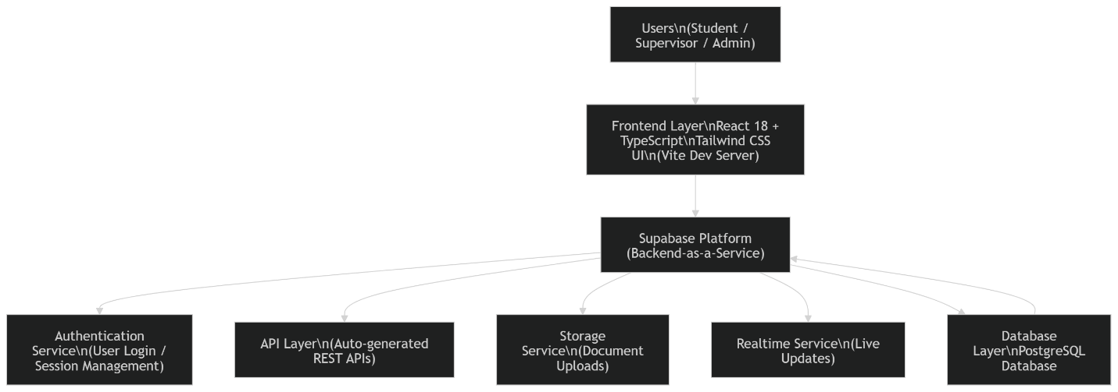

3.3. 3.3.1 Architecture Overview
The system adopts a modern three-tier (3-tier) architecture integrated with a Backend-as-a-Service (BaaS) model. This architecture separates the application into three distinct layers: the Presentation Layer, the Application Layer, and the Data Layer.
Unlike traditional systems that rely on a custom backend server, this system leverages Supabase to handle backend operations such as authentication, API management, and real-time data communication. This approach improves development efficiency and scalability.
3.3.2 Presentation Layer
This layer represents the user interface through which users interact with the system.
- Built using React 18 with TypeScript for component-based development
- Styled using Tailwind CSS for responsive and modern UI design
- Powered by Vite for fast development and build optimization
- Handles user inputs and displays outputs dynamically
- Provides interfaces for:
  - User login and authentication
  - Logbook submission
  - Dashboard navigation
  - Viewing feedback and status updates
The presentation layer communicates directly with backend services via API calls provided by Supabase.

3.3.3 Application Layer
This layer contains the business logic and processing mechanisms of the system.
- Implemented using Supabase (Backend-as-a-Service)
- Handles:
  - User authentication and session management
  - Data validation and processing
  - API request handling
  - Real-time updates (e.g., logbook status changes)
Supabase automatically provides RESTful APIs and integrates authentication, eliminating the need for a traditional PHP-based backend.
Additionally, the Node.js runtime environment is used during development to support frontend tooling and build processes.

3.3.4 Data Layer
This layer is responsible for data storage, retrieval, and management.
- Implemented using PostgreSQL via Supabase
- Stores:
  - Student records
  - Logbook entries
  - Supervisor data
  - Feedback and approval status
The database enforces data integrity through constraints and relationships, ensuring consistency and reliability of stored information.

3.3.5 Justification of Architecture
The chosen architecture is suitable for the system for the following reasons:
- Scalability:
The use of Supabase allows the system to scale easily as the number of users increases
- Improved Security:
Authentication and access control are managed securely through Supabase services
- Separation of Concerns:
The three-tier structure clearly separates the user interface, logic, and data storage
- Reduced Development Complexity:
Backend services such as API creation and authentication are handled automatically
- Ease of Maintenance:
Each layer can be updated independently without affecting the entire system
- Real-Time Capability:
Supports live updates, such as instant feedback on logbook submissions

3.4 System Design

3.4.1 Use Case Diagram
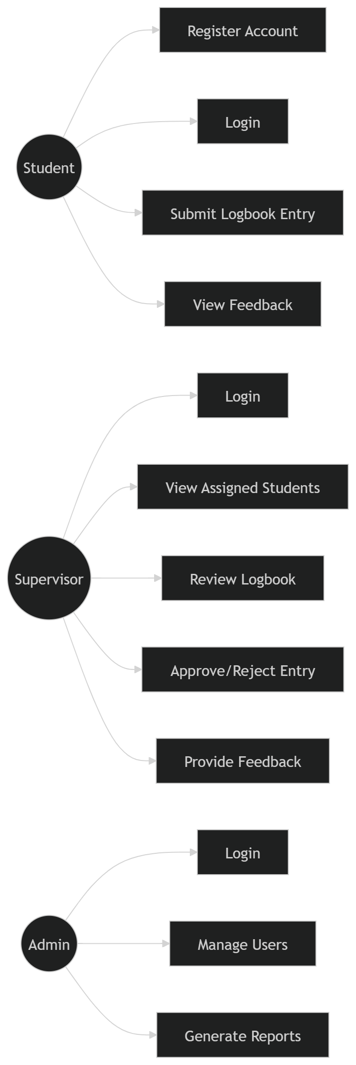

Detailed Explanation
This diagram shows how Student, Supervisor, and Admin interact with the system. Each actor performs specific functions, ensuring proper role separation.

Actors Identified
- Student
  - Primary user of the system
  - Responsible for submitting logbook entries
- Supervisor
  - Reviews and evaluates student submissions
- Administrator
  - Manages system operations and users

Use Case Functions
Student Functions
- Register account
- Login to system
- Submit daily/weekly logbook entries
- View submission status
- Receive feedback
Supervisor Functions
- Login
- View assigned students
- Review logbook entries
- Approve or reject submissions
- Provide feedback/comments
Administrator Functions
- Create/manage users
- Monitor system activities
- Generate reports

Importance
This diagram ensures that:
- System functionalities are clearly defined
- User roles are properly separated
- Access control is maintained

3.4.2 Entity Relationship Diagram (ERD)
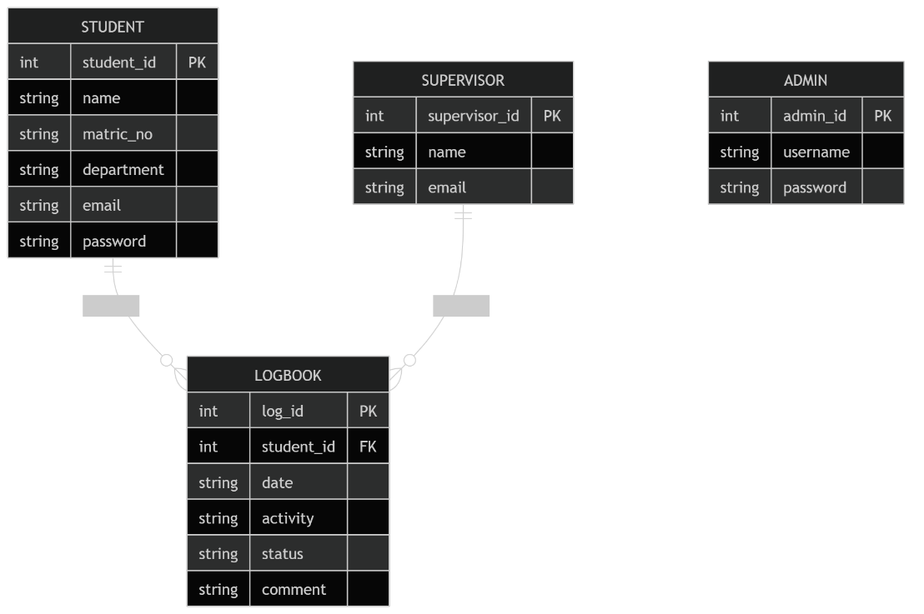

Detailed Explanation
The ERD describes how data is structured and related within the system.

Entities and Attributes
Student
- student_id (Primary Key)
- name
- matric_no
- department
- email
- password
Supervisor
- supervisor_id (Primary Key)
- name
- email
Logbook
- log_id (Primary Key)
- student_id (Foreign Key)
- date
- activity
- status
- comment
Admin
- admin_id (Primary Key)
- username
- password

Relationships
- A Student can have multiple logbook entries
- A Supervisor can review multiple logbook entries
- Each logbook entry belongs to one student

Importance
- Eliminates redundancy
- Ensures data consistency
- Supports efficient querying

3.4.3 Database Design (Relational Schema)

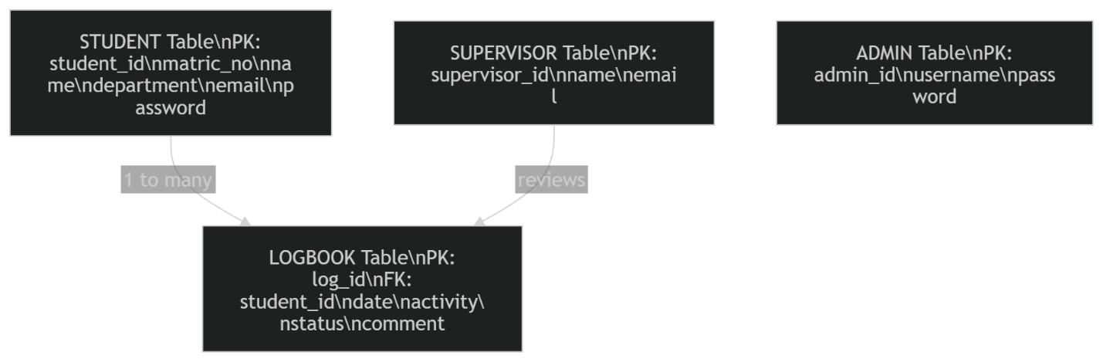

Schema Description
The database of the e-SIWES Logbook System is designed using a relational model, where data is organized into structured tables that are logically connected through keys. Each table represents a specific entity within the system, and relationships between tables ensure efficient data storage, retrieval, and management.
The major tables in the system include:
- Student Table
- Supervisor Table
- Admin Table
- Logbook Table
These tables are interconnected to support core system operations such as logbook submission, supervision, and user management.

Primary Keys (PK)
Primary keys are unique identifiers assigned to each record within a table. They ensure that each entry can be uniquely identified and accessed without duplication.
Examples in the system include:
- student_id in the Student table
- supervisor_id in the Supervisor table
- admin_id in the Admin table
- log_id in the Logbook table
These keys are automatically generated and serve as the foundation for establishing relationships between tables.

Foreign Keys (FK)
Foreign keys are used to establish relationships between tables by referencing the primary key of another table.
In this system:
- The student_id in the Logbook table acts as a foreign key referencing the Student table
- This ensures that every logbook entry is linked to a valid student
Foreign keys help maintain referential integrity, ensuring that data relationships remain consistent across the database.

Normalization
The database is designed following the principles of the Third Normal Form (3NF) to ensure efficiency and eliminate redundancy.
The normalization process ensures that:
- Each table contains data related to a single entity
- Redundant data is eliminated
- Data dependencies are logical and well-structured
By applying 3NF:
- Duplicate data storage is minimized
- Data anomalies during insertion, update, and deletion are prevented
- The database remains scalable and maintainable

Data Integrity Measures
To ensure the accuracy, consistency, and reliability of data within the system, several integrity constraints are implemented:
1. Constraint Enforcement
- NOT NULL constraints ensure that essential fields cannot be left empty
- UNIQUE constraints prevent duplicate entries (e.g., matric number, email)

2. Referential Integrity
- Enforced through foreign keys
- Ensures that a logbook entry cannot exist without a valid student record

3. Data Validation
- Input validation is performed at both the application and database levels
- Prevents invalid or inconsistent data from being stored

3.4.4 System Flowchart
System Flowchart of the e-SIWES Logbook System
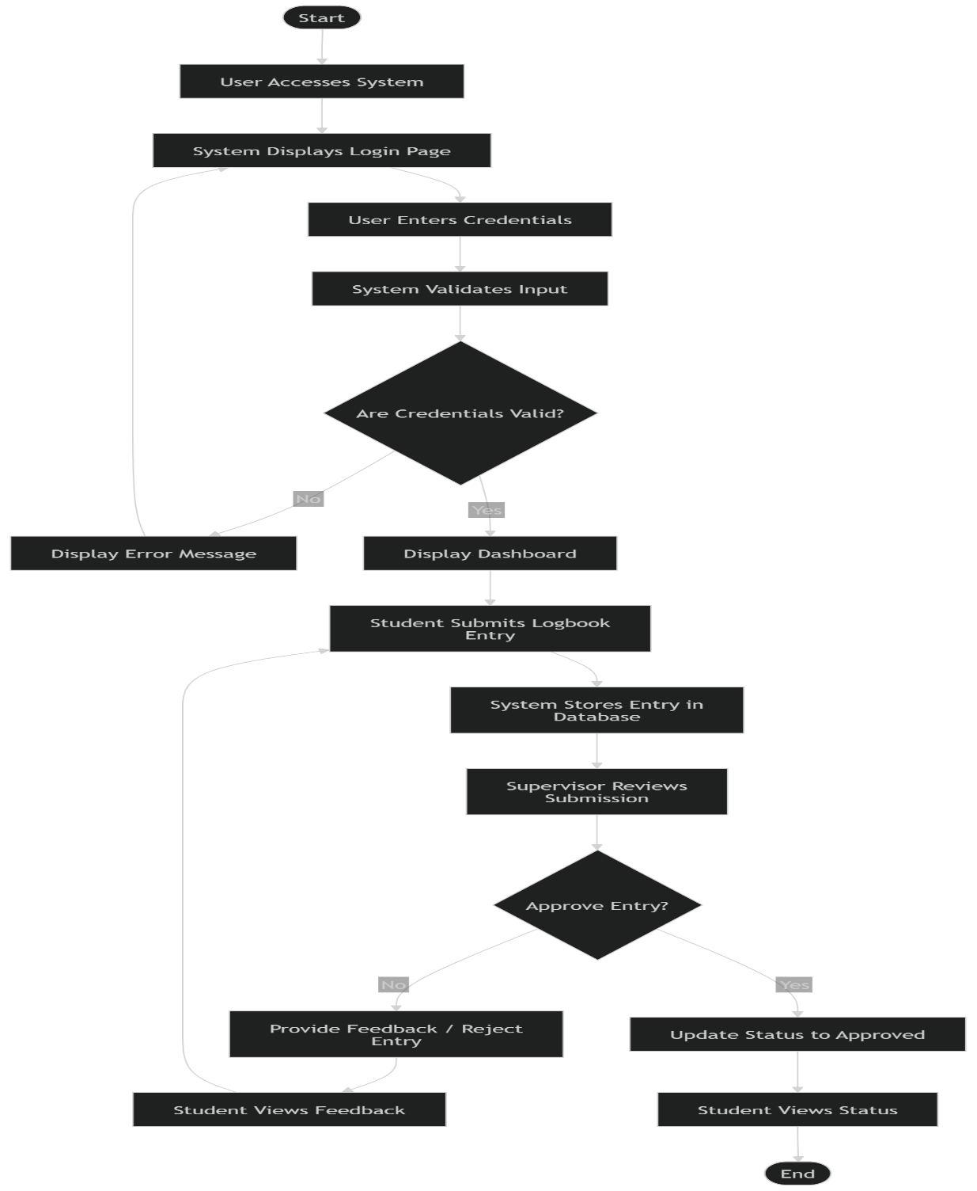

Detailed Explanation
The flowchart illustrates the sequence of operations in the e-SIWES Logbook System, starting from user access to final feedback and status update.
The process begins when a user accesses the system and is prompted to log in. The user enters their credentials, which are validated by the system. If the credentials are invalid, an error message is displayed, and the user is required to re-enter the correct details.
Once validated, the user is granted access to the dashboard. The student proceeds to submit a logbook entry, which is stored in the database. The supervisor then reviews the submitted entry.
At the decision point, the supervisor either approves or rejects the logbook entry. If approved, the system updates the status accordingly. If rejected, feedback is provided to the student, who can review the feedback and resubmit the corrected entry.
Finally, the student views the status or feedback, completing the workflow.

Step-by-Step Process
- User accesses system
- System prompts for login
- User enters credentials
- System validates input
- If valid → Dashboard
- Student submits logbook entry
- System stores entry in database
- Supervisor reviews submission
- Decision point:
  - Approve → Status updated
  - Reject → Feedback provided
- Student views feedback

Importance
- Clarifies system workflow.
- Identifies decision points.
- Improves system understanding.

3.4.5 Input and Output Design
Input Design
Inputs include:
- Login credentials
- Logbook entries
- Supervisor comments
Design considerations:
- Simplicity
- Validation
- Error prevention

Output Design
Outputs include:
- Submission confirmation
- Feedback messages
- Reports
Design considerations:
- Clarity
- Accuracy
- Readability

3.5 Methodology
3.5.1 Development Model: Waterfall Model
The development of the e-SIWES Logbook System followed the Waterfall Model, a traditional software development approach characterized by a linear and sequential progression of phases. This model was selected because it provides a clear structure, well-defined stages, and thorough documentation at each phase of development.
In the Waterfall model, each phase must be completed before proceeding to the next. This ensures that the system is carefully planned, designed, implemented, and tested in an organized manner. The model is particularly suitable for academic projects where requirements are relatively stable and well understood from the beginning.
The development process for the e-SIWES Logbook System was divided into the following phases:

1. Requirement Analysis
This is the first and most critical phase of the system development process. It involves identifying, analyzing, and documenting the requirements of the proposed system.
During this phase:
- The limitations of the existing manual SIWES logbook system were examined.
- Key stakeholders (students, supervisors, and administrators) were identified.
- Functional requirements such as user registration, login, logbook submission, and review were defined.
- Non-functional requirements such as system security, usability, and reliability were also specified.
The outcome of this phase was a clear understanding of what the system is expected to achieve and the features it must include.

2. System Design
In this phase, the conceptual model of the system was transformed into a technical blueprint. The system architecture, data structures, and interaction models were carefully designed.
Activities carried out include:
- Designing the three-tier system architecture (presentation, application, and data layers)
- Creating system diagrams such as:
  - Use Case Diagram
  - Entity Relationship Diagram (ERD)
  - Flowchart
- Designing the database schema and relationships between entities.
- Defining input and output structures.
This phase ensured that the system had a solid structural foundation before implementation began.

3. Implementation
The implementation phase involves translating the system design into actual code using appropriate programming tools and technologies.
During this phase:
Frontend: The frontend was developed using React 18 with TypeScript, leveraging a component-based architecture for modular and maintainable user interfaces. Tailwind CSS 4 was used for styling, while Radix UI and Material UI provided accessible, pre-built UI components. Client-side routing was implemented using React Router DOM v7.
Backend: The backend logic was implemented using Supabase, a Backend-as-a-Service (BaaS) platform that provides authentication, database access, and real-time capabilities through a JavaScript SDK. No traditional server-side language (e.g., PHP) was used; all server operations are handled by Supabase's managed infrastructure.
Database: The database was created using PostgreSQL (managed by Supabase) to store and manage system data including user profiles, logbook entries, supervisor feedback, and administrative records.
Build Tooling: The project was scaffolded and bundled using Vite, a modern frontend build tool that provides fast development server and optimized production builds.
Core Modules: Core modules such as login, user registration, logbook submission, supervisor review, feedback, and admin management were developed as React components with dedicated service layers for data operations.
Each component of the system was coded according to the design specifications established in the previous phase.

4. Testing
Testing is carried out to ensure that the system operates correctly and meets the specified requirements. It is a critical phase for identifying and correcting errors.
The following testing techniques were applied:
- Unit Testing: Individual modules such as login, logbook submission, and feedback were tested independently.
- Integration Testing: Ensured that different modules worked together without errors.
- User Testing: Evaluated the system from the perspective of end users to ensure usability and clarity.
Testing helped to verify that:
- The system functions correctly.
- Data is stored and retrieved accurately.
- Errors are minimized.

5. Deployment
Deployment is the final phase of the development process where the system is made available for use.
In this phase:
- The system was deployed on Render, a cloud-based hosting platform, while the backend services were hosted on Supabase's cloud infrastructure.
- Users such as students and supervisors could access the platform through a web browser.
- Final adjustments and minor corrections were made after initial usage.

Deployment ensures that the system is fully operational and ready for real-world application.

3.5.2 Justification of Methodology
The choice of the Waterfall model for the development of this system is justified based on several factors:
- Structured and Sequential Approach:
The model provides a clear step-by-step process, making development easy to follow and manage.
- Ease of Understanding:
Each phase is well-defined, making it suitable for academic environments where clarity is essential.
- Thorough Documentation:
Documentation at each stage ensures that the development process is properly recorded and can be reviewed.
- Suitability for Stable Requirements:
The requirements of the e-SIWES Logbook System are well understood, making the linear approach effective.
- Ease of Maintenance:
The structured nature of the model makes it easier to update and maintain the system in the future.
- Project Control and Monitoring:
Progress can be easily tracked since each phase has specific deliverables.

